# Error Logger Manual

The Error Logger is an application that fetches both application and system errors from critical servers that need constant monitoring such as the cluster servers.

## Languages used

1. The main interface runs on HTA for the front-end and VBScript for back-end.
2. The core of the system runs on PowerShell which is used to access the servers remotely and fetch their error logs saving them as csv files.
3. The reporting is done on an Excel application using Visual Basic that reads from CSVs created by the PowerShell script above.

## User Interface

### Installing the application and launching it

1. Access the folder where the application is running from. Currently: \\10.80.101.25\Application\The EventLogger\

This can be done by opening Run by pressing Windows key + R and pasting the path then clicking on OK.

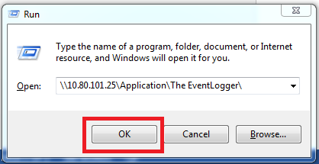

1. Copy the application shortcut to any location on your machine, for instance, your desktop.

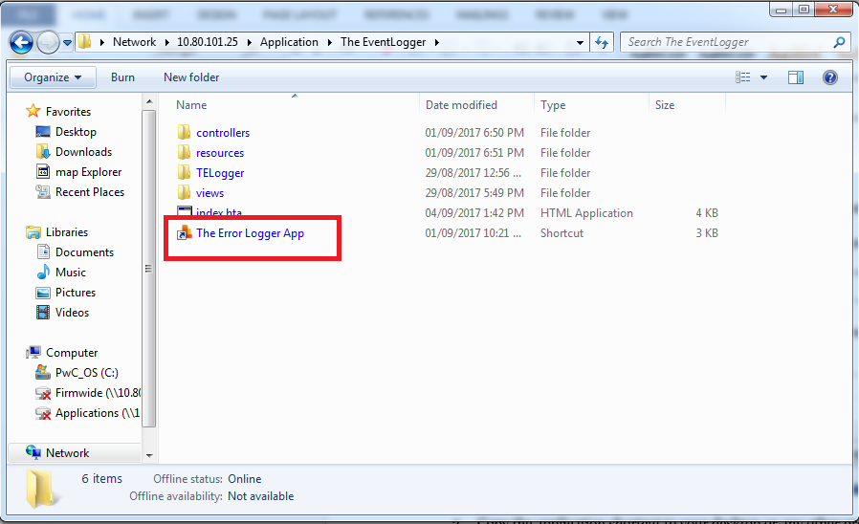

1. Double click on the shortcut you have copied to your machine. Click on Run on the prompt that will appear.

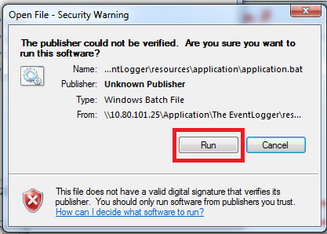

This will copy all necessary files (such as CSS files and scripts) from the server to your local machine to allow smooth running of the application.

1. The following application interface will now load.

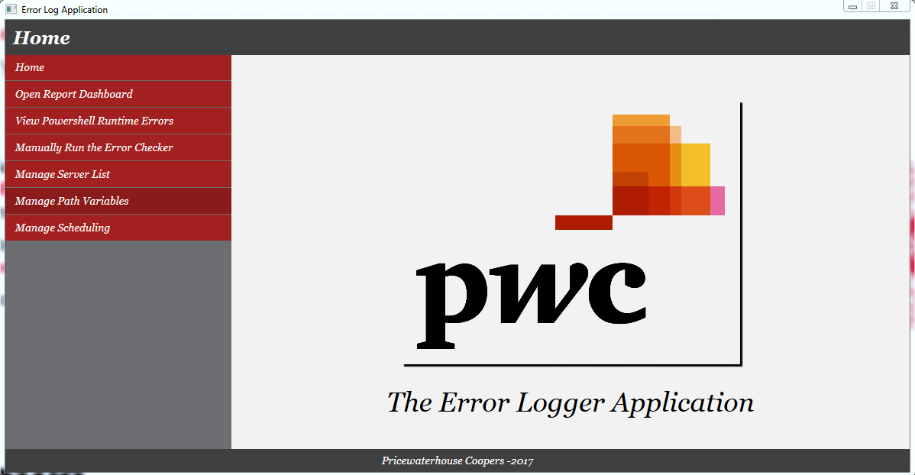

### Opening the excel report

1. From the Nav Bar on the application interface, click on ‘Open Report Dashboard’

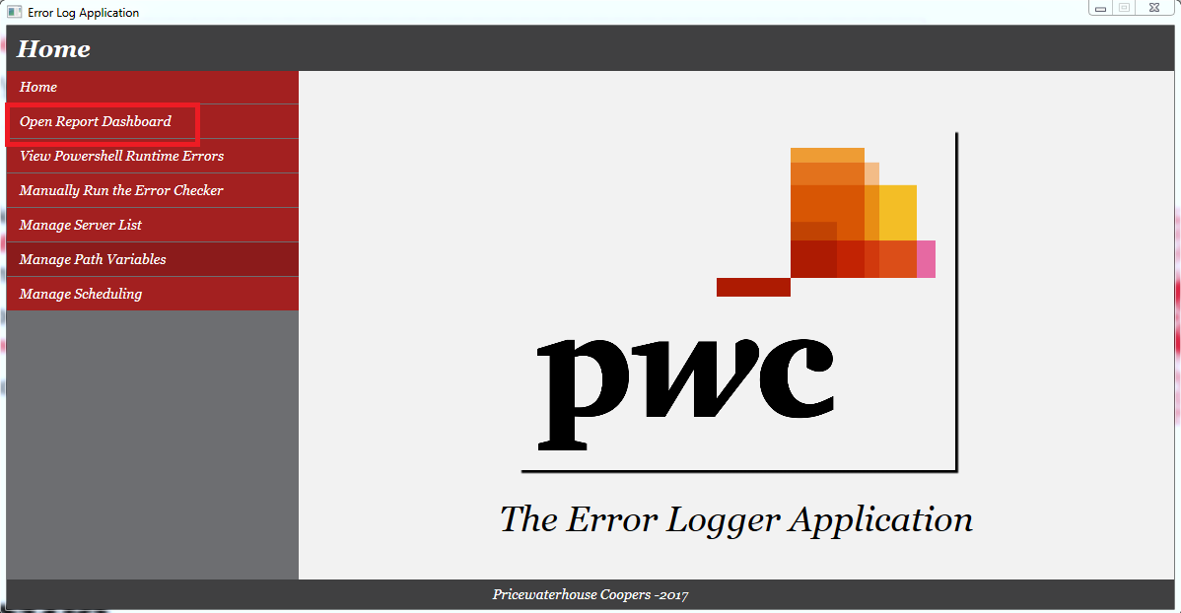

This will open an excel application instance with the reporting dashboard. To see how to use the excel dashboard, see the next section.

### Viewing runtime errors

1. From the Nav Bar on the application interface, click on ‘View Powershell Runtime Errors’

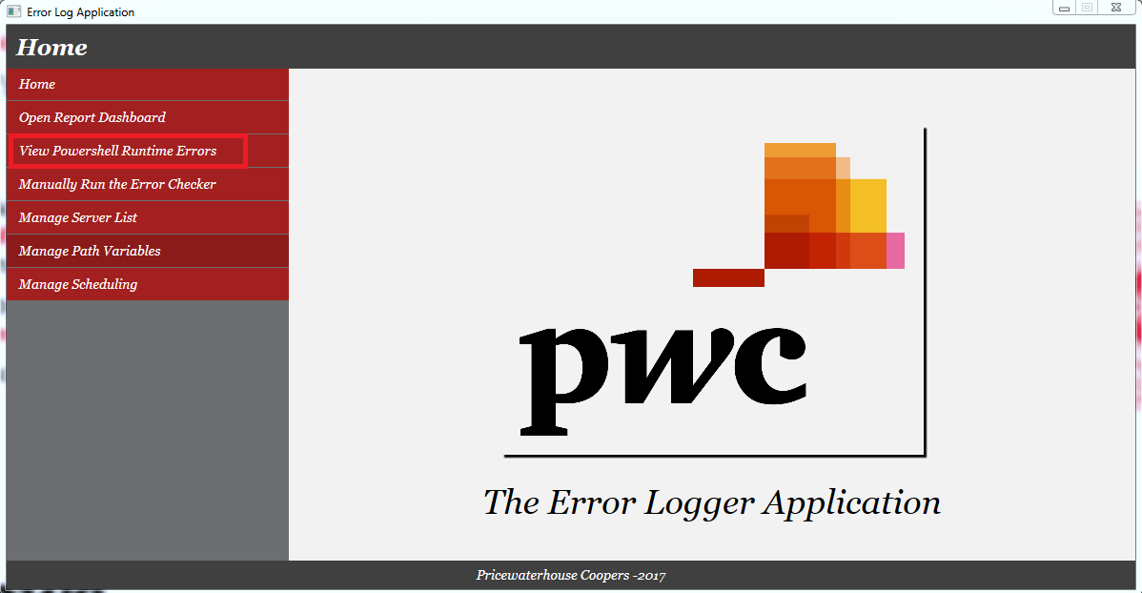

This will open a text file with all errors encountered during the runtime of the PowerShell script.

### Running the error logger manually

1. From the Nav Bar on the application interface, click on ‘Manually Run the Error Checker’

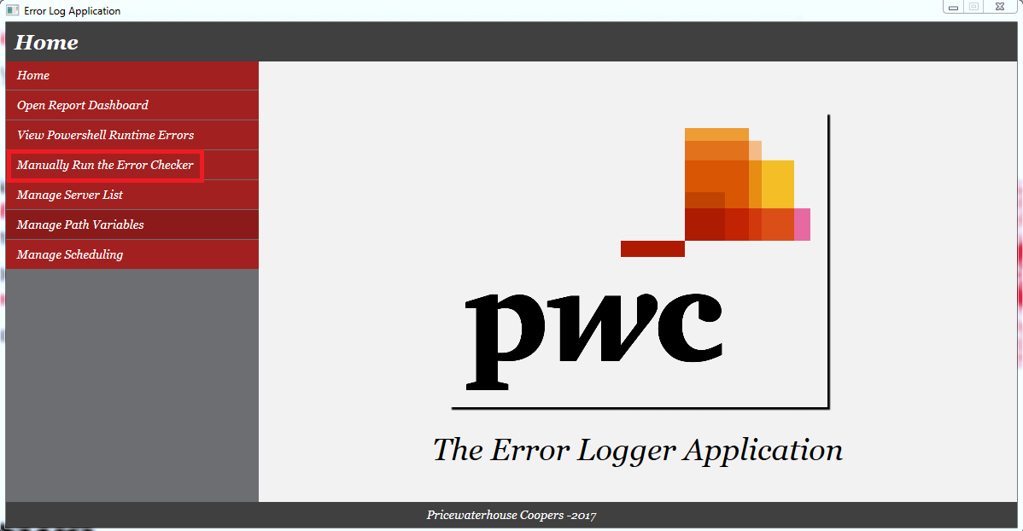

1. On the prompt that appears, click on Run



1. This will then open and close an instance of Command Prompt and PowerShell CLI each. The script will continue to run in the background until it’s completion after which it will open an excel application containing the report dashboard with updated data.

### Managing servers

1. From the Nav Bar on the application interface, click on ‘Manage Servers’

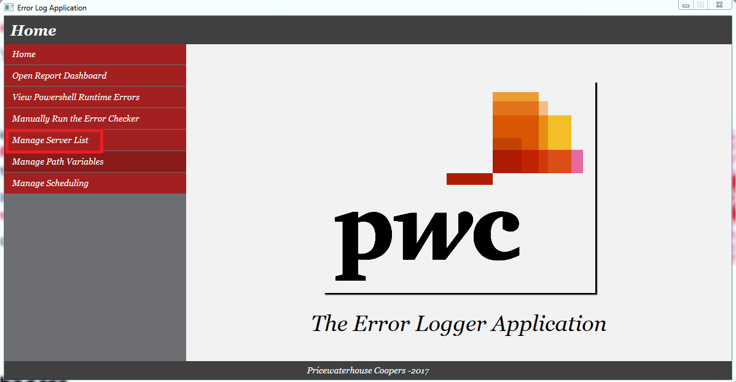

1. That will load the following interface

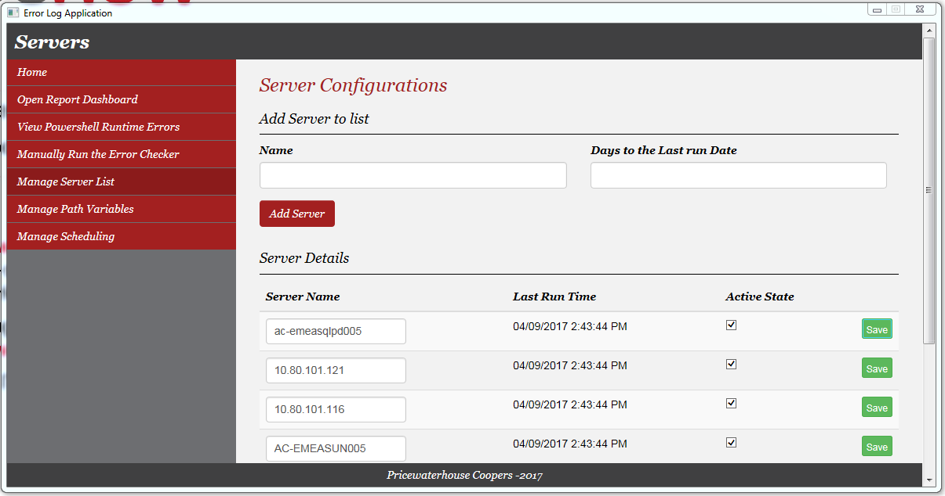

#### Adding a server

1. Under the heading ‘Add Server to list’ enter the server name and the number of days from the current date you would like the application to fetch the logs. This will be saved as the initial last run date - a field that is updated each time the script runs to avoid redundancies in the data.

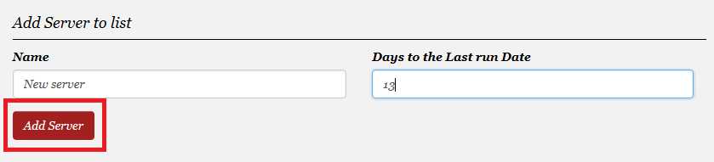

#### Editing a server

1. Under the heading ‘Server Details’ you can choose to edit the server name, activate or deactivate the server from having it’s logs checked. These changes must be saved to ensure they are reflected on the database table.

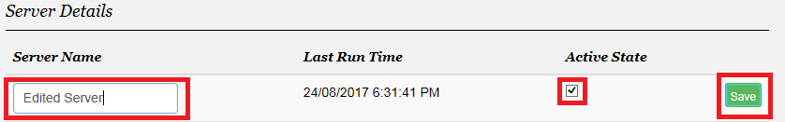

hard-deleting a server is only possible from the database. this is to avoid erroneously deleting a server from the list.

### Managing paths

1. From the Nav Bar on the application interface, click on ‘Manage Paths Variables’

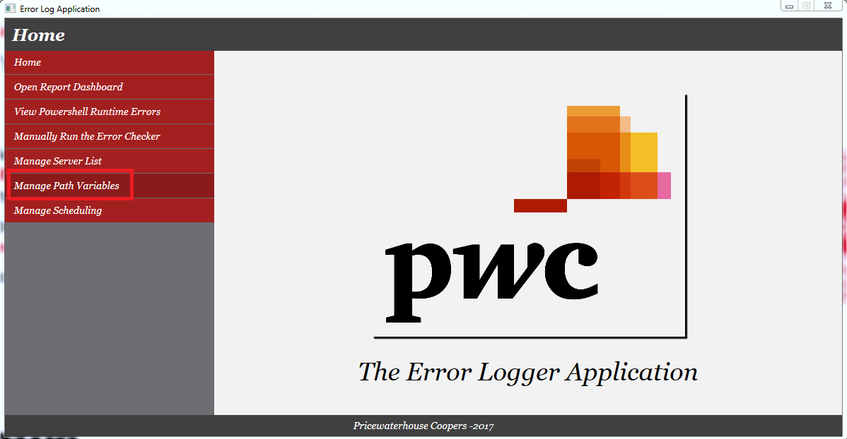

1. That will load the following interface

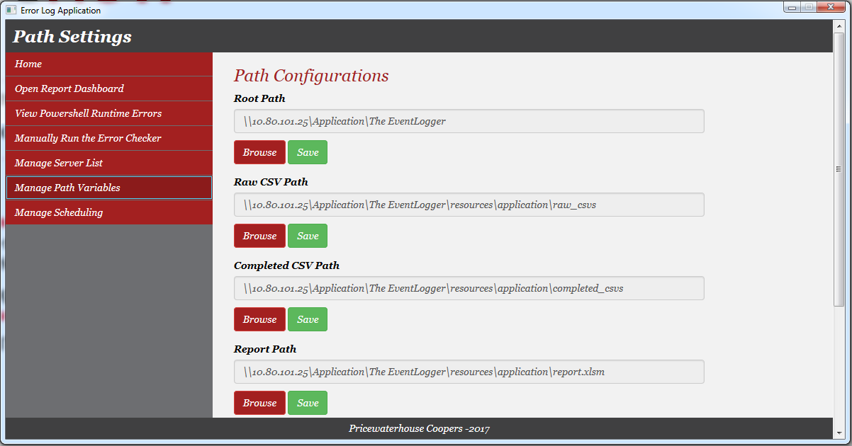

1. To change a path, click on Browse
2. On the folder picker that appears, navigate to the folder of choice and click on OK
3. Click on Save to push the updates to the database.

### Scheduling the tracker

1. From the Nav Bar on the application interface, click on ‘Manage Scheduling’

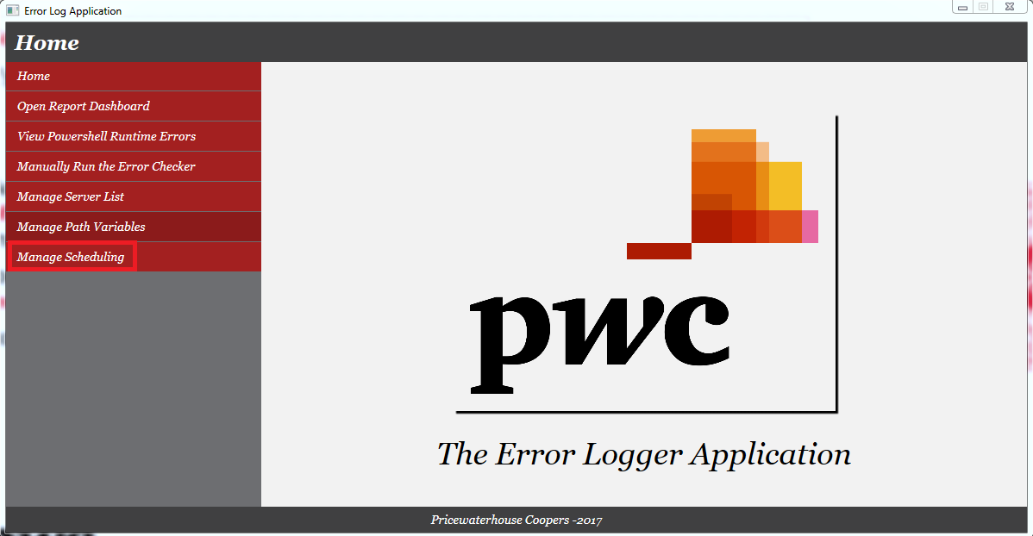

1. From the Nav Bar on the application interface, click on ‘Manage Paths Variables’

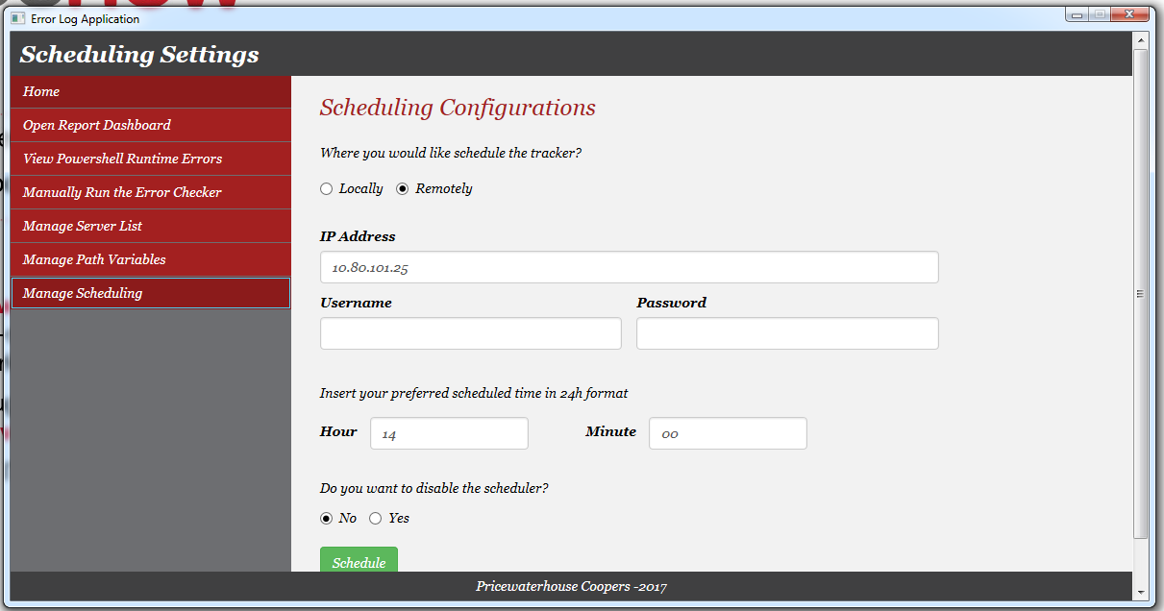

### Scheduling locally

1. Pick locally
2. Enter the time
3. Click No to enable the scheduler
4. To disable the scheduler, click on Yes
5. Click on schedule
6. Open and closes an instance of command prompt

### Scheduling remotely

1. Pick remotely
2. Enter IP address, user name and password for the remote machine
3. Enter the time
4. Click No to enable the scheduler
5. To disable the scheduler, click on Yes
6. Click on schedule
7. Opens and closes an instance of command prompt
8. It may ask for a password on command prompt. Enter the password for the remote machine and press enter

## Excel report

1. Refreshing
2. Filtering
3. Admin mode
4. Developer Vba code
5. Power query

## Database

1. Tables
2. Credentials
3. Migrations

## Troubleshooting Common Errors

1. Security
2. Power query